| **Problem Statement : Online Bus Reservation System** | | | | | | | | | |
| --- | --- | --- | --- | --- | --- | --- | --- | --- | --- |
| **What ? 1** | | | | | **How ? 2** | | | | |
| 1) What are the functionalities or Modules Required?  ***Ans:***  **1) Admin**  a) Add the Bus  **Ans:** Bus no, Bus type(Ac/Non-Ac), Bus Name & No of seats  b) Update the Bus  **Ans:** Source and destination details  c) Delete the Bus  **Ans:** If there is any issues in the bus  d) View/View all the Bus details and driver details  **Ans:** Bus no, Bus type(Ac/Non-Ac), Bus Name & Driver Name, Mobile Number  e) Add/Delete/Update/View fare details  f) Add/Delete/Update/View Customer details  **Ans:** Mobile Number, Email  **2) User**  a) Register  b) Login  c) Search a Bus  d) Book a Bus  e) Cancel a Bus  f) Payment  g) Review  h) Travel History  2) What type of application do you need: Mobile app or Web application?  ***Ans:*** Mobile Application  3) What is the deadline for this project?  **Ans:** Approximately it may take 4 to 6 months | | | | | **For the Admin**  1. In the admin panel in bus details using text box for bus id with delete,add,update,view,fare option.  2. In the admin panel in bus details using a drop down box for bus id with delete,add,update,view,fare option.  3. In the admin panel in bus details by listing the bus id with details,delete,add,update,view,fare option.  4. In fare enter route in text bar add,delete,update option.  5. In fare select the source and destination add,delete,update option.  6. In customer details with customer id in text box with add,update,delete,view option.  7. In customer details with customer id in drop down with add,update,delete,view option.  8. In customer details listing with customer id with add,update,delete,view option.  9. In driver or cleaner details with id in textbox with add,update,delete,view option.  10. In driver or cleaner details with id in drop down with add,update,delete,view option.  11. In driver or cleaner details listing with id add,delete,update,view option.  **For the User :**  12. User page after login search by source,destination and time and listing the available bus by time.  13. User page after login search by bus name and recent route.  14. User page after login search bar for destination and time and display the available buses.  15. Choose the bus for travel and select the book ticket option to book.  16. Choose the bus and click the full details of travel route time after book ticket.  17. Provide the review link for the user to give a review about the travel.  18. Provide the review option after the book ticket in the app itself.  19. Display the tracking by using the location access and show the traveling area.  20. Displaying the recent history from the recent button in separate.  21. Recent history under the search bars. | | | | |
| **Why ? 3** | | | | | **Why Not ? 4** | | | | |
| 1. In admin panel in bus details it list the bus details by name  and route means it will be easy for it to be deleted or updated.  2. In fare selecting will be easy to choose the source and  destination and enter the fare details.  3. In customer details listing will be easier to delete and to add,  delete and view.  4. In driver details listing with id it is easy to find the driver by  name, area to delete,update and view.  5. User can directly focus on which buses are available by  that date and choose the time on their own.  6. Booking ticket after seeing the full details that the user  will clarify that they can book this bus or other buses.  7. Review option in the app it will store with customer id  and easy to show the other about our reviews.  8. Recent history will be in private after clicking show only  display the recent bookings | | | | | 1. In the admin panel in bus details we can't remember every bus id on our own.  2. In select down it doesn't show the details from outside to delete we need to go view after delete.  3. In fare details entering the source and destination by remembering the area is difficult.  4. Entering customer details and selecting the customer only using customer id is difficult.  5. Driver details entering and selecting only using id is difficult.  6. Searching for a bus by name is more complicated and destination is also difficult.  7. Booking bus ticket without seeing full detail of bus is not more  efficient. | | | | |

**Write an algorithm for an Online Bus Reservation System.**

**Step 1:** Start

**Step 2:** Create a registration page and login page.

**Step 3:** After login with admin credentialscreate an admin page with three options for pages bus details,customer details and driver & cleaner details.

**Step 4:** In the bus details page it has the list of bus id with details and delete,update,view,fare and add separate option to add new bus details. **Step 5:** In the customer details page it has the list of customer id with details and delete,update,view and add separate option to add new customer details.

**Step 6:** In the driver & cleaner details page it has the list of driver id with details and delete,update,view and add separate option to add new driver details.

**Step 7:** After login with user credentials create a user page with source,destination drop down with location.

**Step 8:** Under that date selection button and separate option for recent history.

**Step 9:** After this page the bus listing page with the source,destination and date given by the user.

**Step 10:** After selecting the bus from that page it will display the details of travel route,time,reviews and book ticket option.

**Step 11:** After selecting the book ticket option it displays the payment option upi and card.

**Step 12:** After booking a ticket it displays the review page to get review for the app and also for the bus travel after the user completed the travel.

**Step 13:** In selection of recent history in the home page it displays the recent booked tickets.

**Step 14:** Stop.

**FLOWCHART**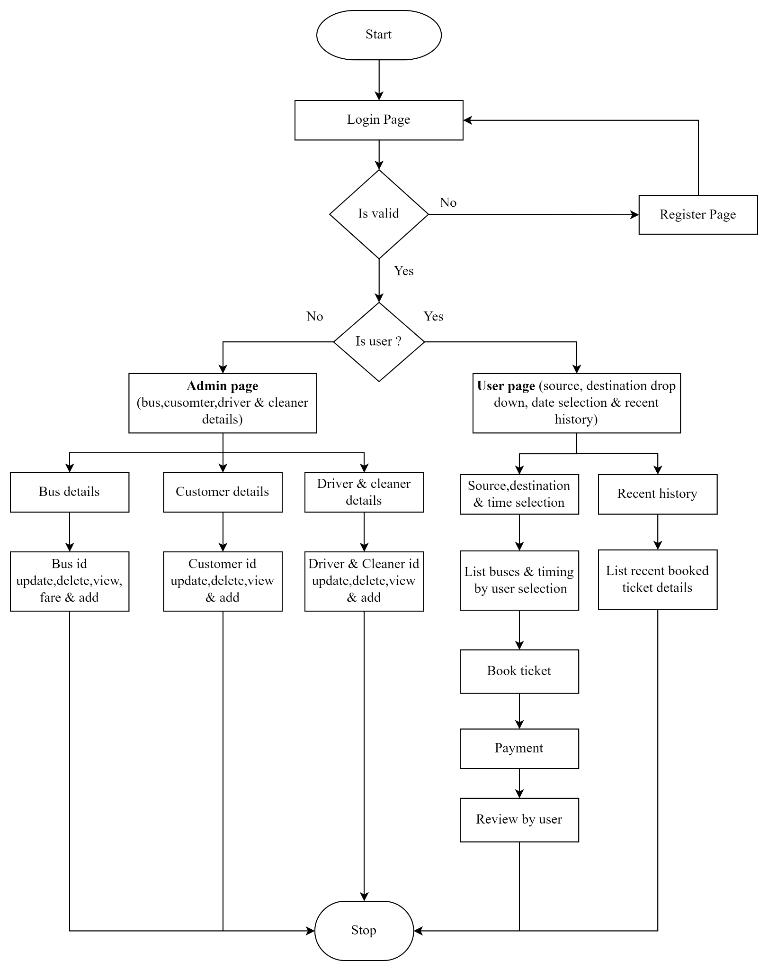

**CLASS DIAGRAM:**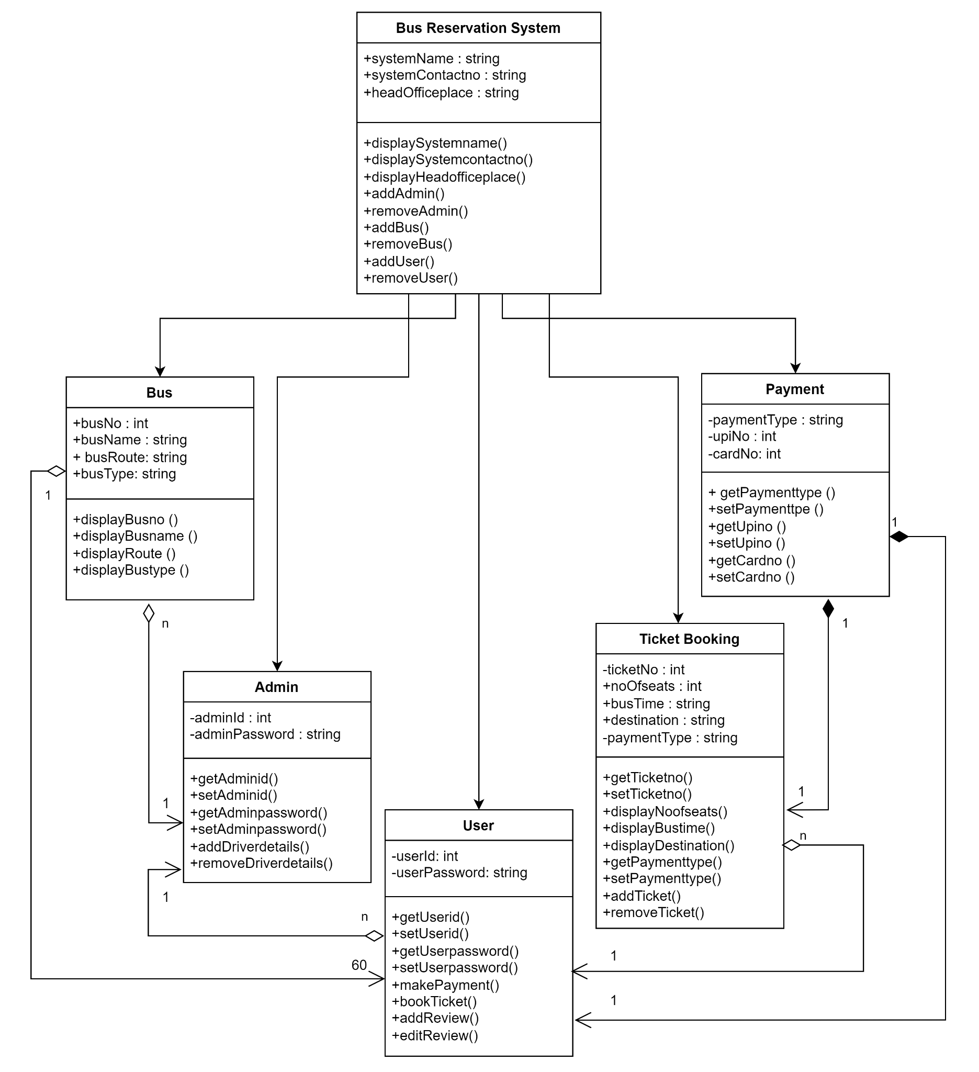

**USE CASE DIAGRAM:**

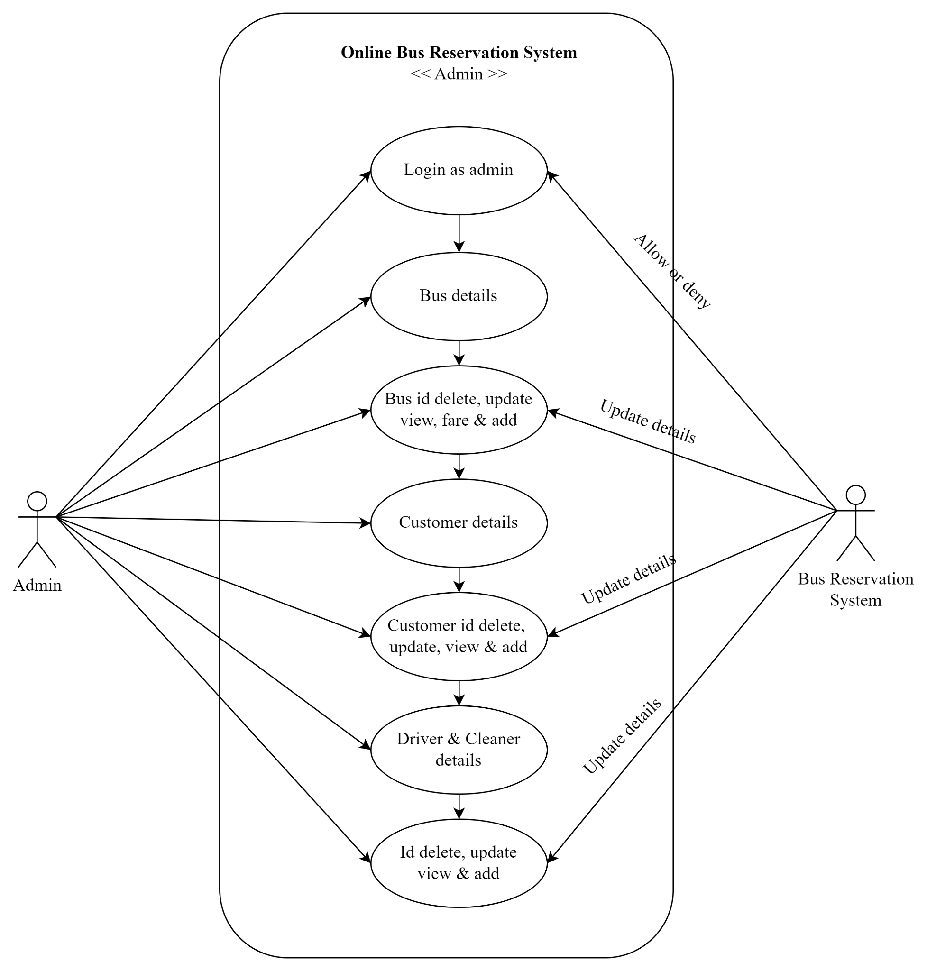

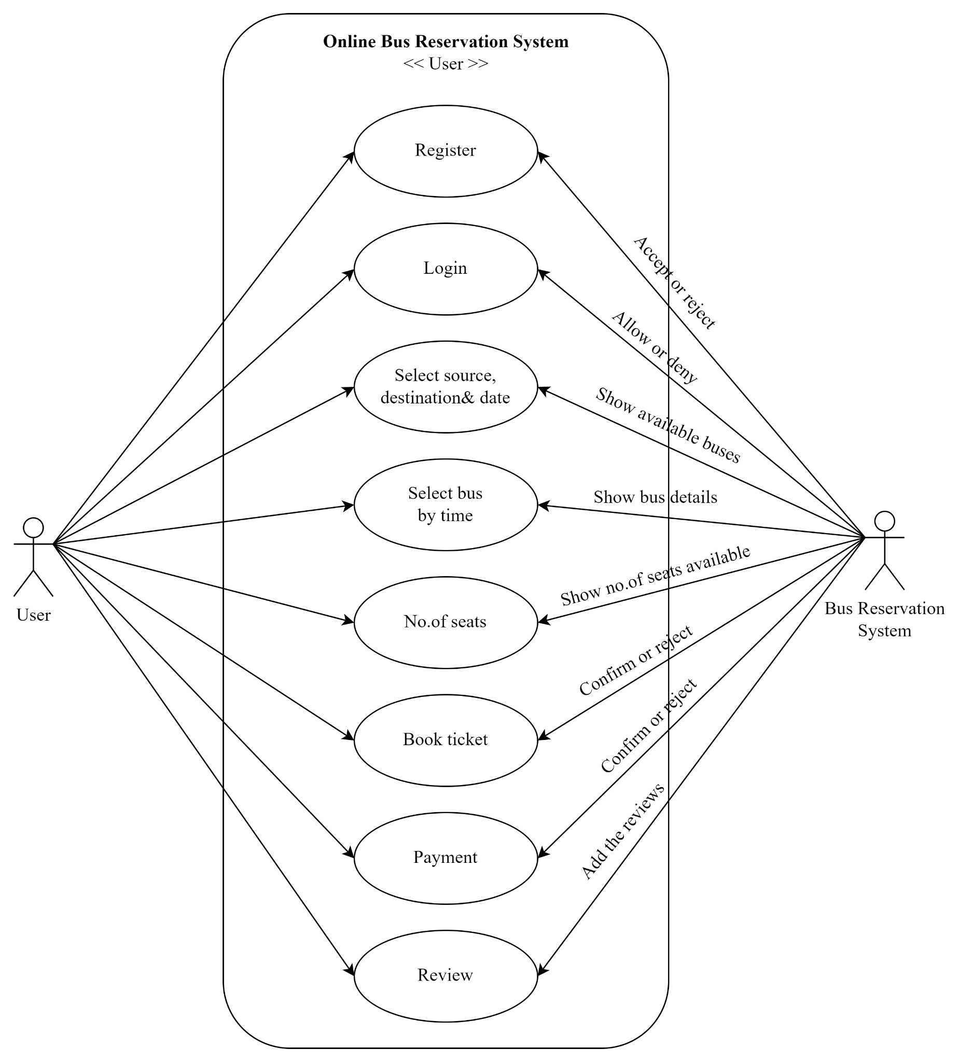

**SEQUENCE DIAGRAM:**

